**Azure SQL Database** automatically handles backups for you as part of its **built-in backup mechanism**, without requiring manual intervention. These backups are crucial for **disaster recovery** and **point-in-time restores**.

**Key Points About Azure SQL Database Backups:**

1. **Automatic Backups**:
   * **Full backups**, **differential backups**, and **transaction log backups** are automatically taken by Azure SQL Database.
   * Azure retains these backups in the **same region** by default, and these backups are stored in **Geo-redundant storage (GRS)**.
2. **Backup Retention Period**:
   * The **default retention period** for backups is **7 to 35 days**, depending on the service tier and performance level you select.
   * **Basic** tier: 7 days retention.
   * **Standard and Premium** tiers: 7 to 35 days retention (configurable).
3. **Point-in-Time Restore**:
   * You can restore your database to any point within the retention period (up to 35 days).
   * This allows you to recover from accidental data loss or corruption.

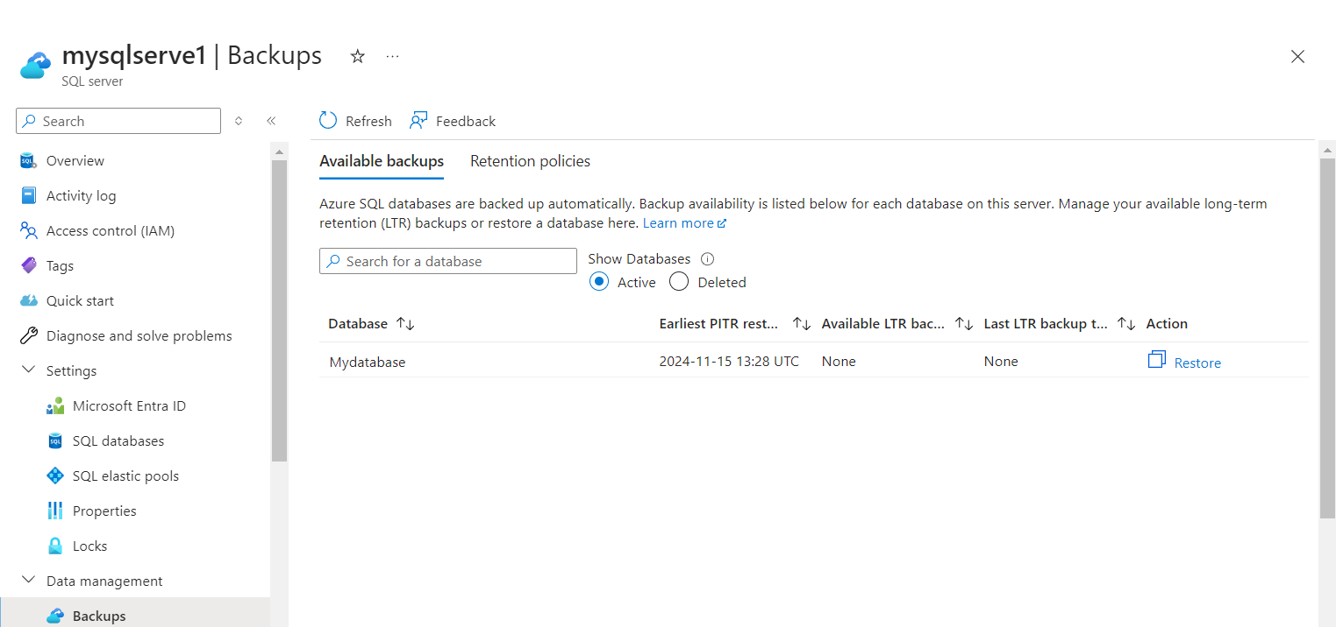

In the context of **Azure SQL Database**, **import** and **export** operations refer to moving data in and out of a database. These operations are useful for tasks such as migrating data, creating backups, or transferring data between environments.

Here's an overview of both operations:

***1. Exporting Data from Azure SQL Database***

Exporting data from Azure SQL Database involves creating a **BACPAC** file, which contains the schema and data of the database. You can use this BACPAC file to move data to another Azure SQL Database or to an on-premises SQL Server.

**Steps to Export Data:**

1. **Using the Azure Portal:**
   * Go to the **Azure Portal**.
   * Navigate to **SQL databases**, then select the database you want to export.
   * In the **Overview** pane, click on **Export** under **Settings**.
   * You will be asked to specify:
     + **Storage account** (where the BACPAC file will be stored).
     + **BACPAC file name**.
     + **Admin username and password** to authenticate the export operation.
   * Once configured, click **OK** to begin the export process. After completion, you can download or move the BACPAC file to another location.

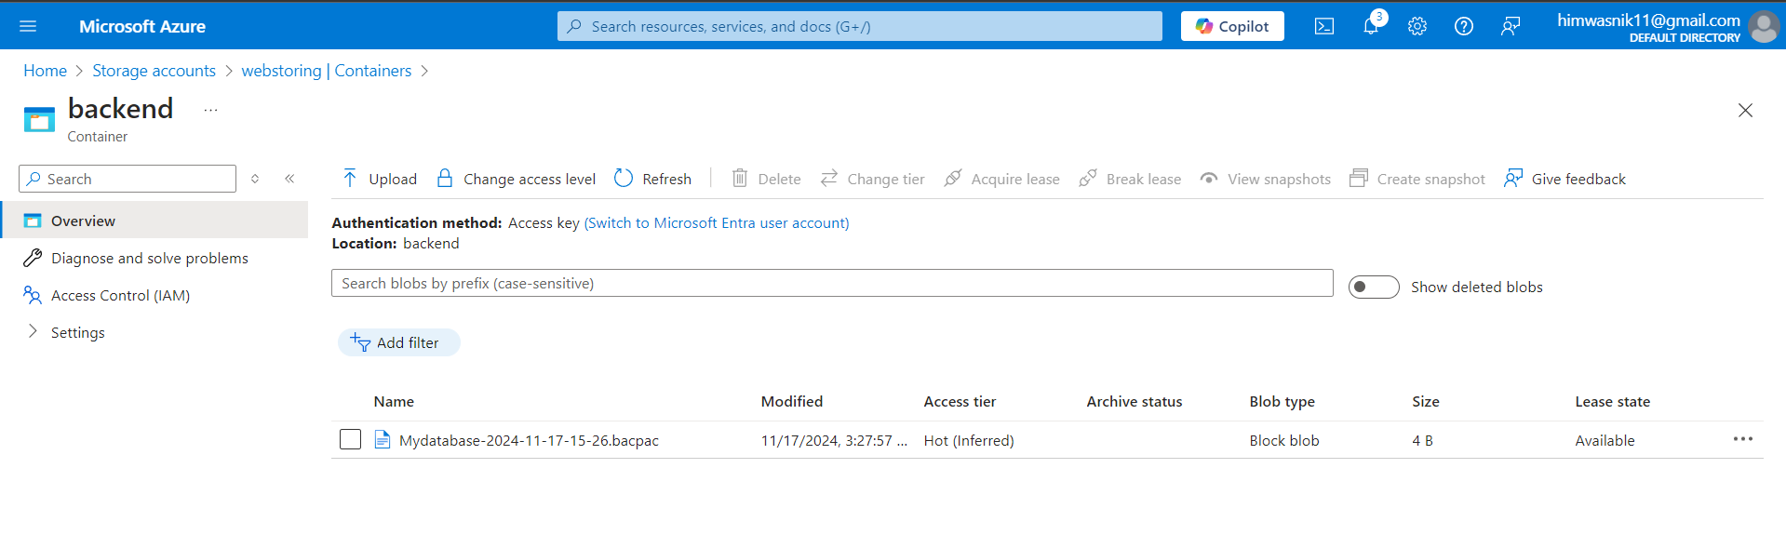

***2. Importing Data into Azure SQL Database***

Importing data involves bringing a **BACPAC** file into a new or existing Azure SQL Database. The BACPAC file contains both the schema and the data.

**Steps to Import Data:**

1. **Using the Azure Portal:**
   * Go to the **Azure Portal**.
   * Navigate to **SQL databases**, and click on **Import** under **Settings**.
   * Select the **BACPAC file** that you want to import.
   * Choose the **Storage account** and **Container** where the BACPAC file is located.
   * Provide **Admin credentials** to authenticate.
   * Click **OK** to start the import. The database will be created with the data from the BACPAC file.

